MySQL work Bench Guide

1. Install the mysql software.
2. Install the official GUI for mysql which the GUI mysqlworkbench
3. Create a schema name for accessing the table always mention the schema name before. Example: schema name = hr

Table name = Departments

Select \* from hr.Departments

1. To execute the sql query click the following icon in the mysql workbench.

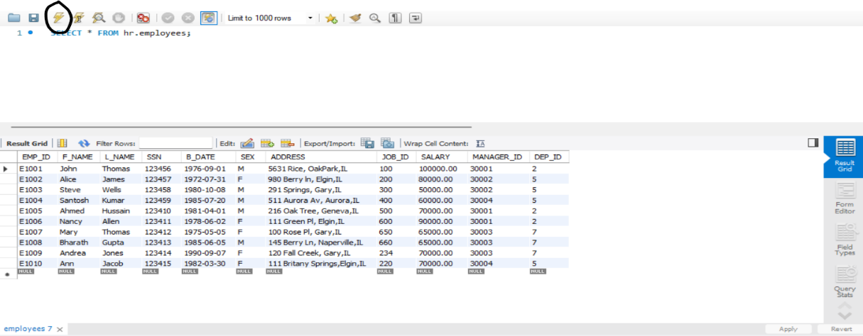

1. Wait for the program specially when creating a table in mysql work bench for a while. The table will appear for a while this is cause by slow computer or lag in the system.